Purpose: Day 4 Classwork and Assignment
Date: 26/12/2025
Author: Vinayak Majhi
ID: 58618

Assignment
(Notepad)

Q.1. 1. Area Calculator
Create overloaded functions named area() to calculate:
Area of a square
Area of a rectangle
Area of a circle

Requirements
Same function name
Different parameter lists
Use appropriate data types

Without Constructor

#include <iostream>
using namespace std;

class Calendar {
int day, month, year;

public:
void setDate(int dd = 1, int mm = 12, int yyyy = 2025) {
day = dd;
month = mm;
year = yyyy;
}

bool isLeap() {
if ((year % 4 == 0 && year % 100 != 0) || (year % 400 == 0))
return true;
return false;
}

int maxDays() {
if (month == 2)
return isLeap() ? 29 : 28;
if (month == 4 || month == 6 || month == 9 || month == 11)
return 30;
return 31;
}

bool valideDate() {
if (month < 1 || month > 12)
return false;
if (day < 1 || day > maxDays())
return false;
return true;
}

int dayOfWeek() {
int d = day, m = month, y = year;
if (m < 3) {
m += 12;
y--;
}
int k = y % 100;
int j = y / 100;
return (d + (13 * (m + 1)) / 5 + k + k / 4 + j / 4 + 5 * j) % 7;
}

void printCalendar() {
cout << "Date: " << day << "/" << month << "/" << year << endl;
}
};

int main() {
Calendar c;
c.setDate(26, 12, 2025);

if (c.valideDate()) {
c.printCalendar();
cout << "Day of Week (0=Sat): " << c.dayOfWeek() << endl;
} else {
cout << "Invalid Date" << endl;
}

return 0;
}

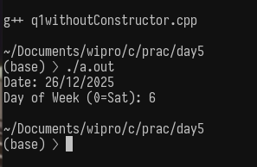
With Constructor

#include <iostream>
using namespace std;

class Calendar {
int day, month, year;

public:
Calendar(int dd = 1, int mm = 12, int yyyy = 2025) {
day = dd;
month = mm;
year = yyyy;
}

bool isLeap() {
return ((year % 4 == 0 && year % 100 != 0) || (year % 400 == 0));
}

int maxDays() {
if (month == 2)
return isLeap() ? 29 : 28;
if (month == 4 || month == 6 || month == 9 || month == 11)
return 30;
return 31;
}

bool valideDate() {
if (month < 1 || month > 12)
return false;
if (day < 1 || day > maxDays())
return false;
return true;
}

int dayOfWeek() {
int d = day, m = month, y = year;
if (m < 3) {
m += 12;
y--;
}
int k = y % 100;
int j = y / 100;
return (d + (13 * (m + 1)) / 5 + k + k / 4 + j / 4 + 5 * j) % 7;
}

void printCalendar() {
cout << "Date: " << day << "/" << month << "/" << year << endl;
}
};

int main() {
Calendar c(26, 12, 2025);

if (c.valideDate()) {
c.printCalendar();
cout << "Day of Week (0=Sat): " << c.dayOfWeek() << endl;
} else {
cout << "Invalid Date" << endl;
}

return 0;
}

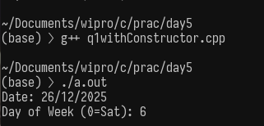

Q.2. Implement the class Num with the given data and methods as given below.
class Num{
int num;
public:
void setNum(int n = 10);
void dispNum();
bool isEven();
bool isPrime();
};

Without Constructor

#include <iostream>
using namespace std;

class Num {
int num;

public:
void setNum(int n = 10) { num = n; }

void dispNum() { cout << "Number: " << num << endl; }

bool isEven() { return (num % 2 == 0); }

bool isPrime() {
if (num <= 1)
return false;

for (int i = 2; i * i <= num; i++) {
if (num % i == 0)
return false;
}
return true;
}
};

int main() {
Num n1;
n1.setNum();
n1.dispNum();
cout << "Even: " << n1.isEven() << endl;
cout << "Prime: " << n1.isPrime() << endl;

Num n2;
n2.setNum(17);
n2.dispNum();
cout << "Even: " << n2.isEven() << endl;
cout << "Prime: " << n2.isPrime() << endl;

return 0;
}

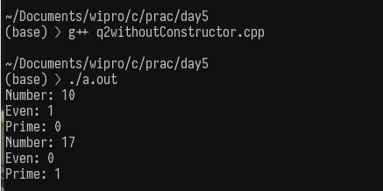

With Constructor

#include <iostream>
using namespace std;

class Num {
int num;

public:
Num(int n = 10) { num = n; }

void dispNum() { cout << "Number: " << num << endl; }

bool isEven() { return (num % 2 == 0); }

bool isPrime() {
if (num <= 1)
return false;

for (int i = 2; i * i <= num; i++) {
if (num % i == 0)
return false;
}
return true;
}
};

int main() {
Num n1; // default value 10
n1.dispNum();
cout << "Even: " << n1.isEven() << endl;
cout << "Prime: " << n1.isPrime() << endl;

Num n2(17); // custom value
n2.dispNum();
cout << "Even: " << n2.isEven() << endl;
cout << "Prime: " << n2.isPrime() << endl;

return 0;
}

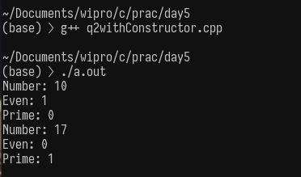

Q.3 Implement the class BankAccount with the given data and methods as given below.
Data:
Account number
Account holder name
Balance
Provide functions to:
setAccount --> Initial value of number, name and balance,
Deposit money
Withdraw money
Display balance

Without Constructor

#include <iostream>
#include <string>
using namespace std;

class BankAccount {
int accNo;
string name;
double balance;

public:
void setAccount(int no, string n, double bal) {
accNo = no;
name = n;
balance = bal;
}

void deposit(double amt) { balance += amt; }

void withdraw(double amt) {
if (amt <= balance)
balance -= amt;
else
cout << "Insufficient Balance!" << endl;
}

void display() {
cout << "Account Number: " << accNo << endl;
cout << "Account Holder: " << name << endl;
cout << "Balance: " << balance << endl;
}
};

int main() {
BankAccount b1;

b1.setAccount(101, "Rahul", 5000);
b1.display();

b1.deposit(2000);
cout << "\nAfter Deposit:\n";
b1.display();

b1.withdraw(3000);
cout << "\nAfter Withdrawal:\n";
b1.display();

return 0;
}

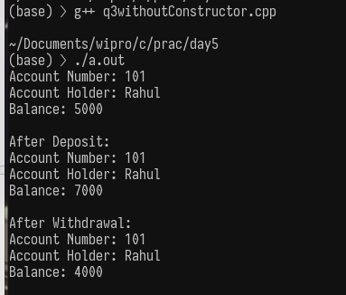

With Constructor

#include <iostream>
#include <string>
using namespace std;

class BankAccount {
int accNo;
string name;
double balance;

public:
// Constructor
BankAccount(int no, string n, double bal) {
accNo = no;
name = n;
balance = bal;
}

void deposit(double amt) {
balance += amt;
}

void withdraw(double amt) {
if (amt <= balance)
balance -= amt;
else
cout << "Insufficient Balance!" << endl;
}

void display() {
cout << "Account Number: " << accNo << endl;
cout << "Account Holder: " << name << endl;
cout << "Balance: " << balance << endl;
}
};

int main() {
BankAccount b1(102, "Anita", 8000);
b1.display();

b1.deposit(1500);
cout << "\nAfter Deposit:\n";
b1.display();

b1.withdraw(4000);
cout << "\nAfter Withdrawal:\n";
b1.display();

return 0;
}
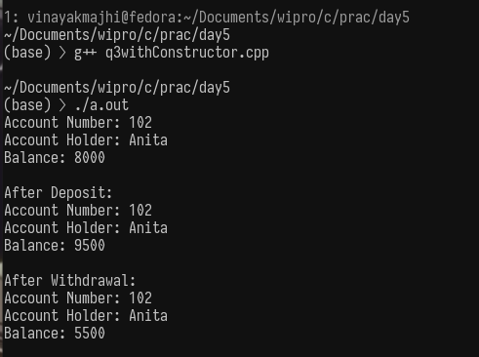

Q.4. Define a class MyArray, you provide constructors (default, single parameterized, copy), printArray(), extend(It will add new contents from an existing array).
class MyArray{
int arr[100];
int size;
public:
MyArray();
MyArray(int data);
MyArray(const MyArray&);
void printArray();
void extend(const MyArray&);
};

#include <iostream>
using namespace std;

class MyArray {
int arr[100];
int size;

public:
MyArray() { size = 0; }

MyArray(int data) {
arr[0] = data;
size = 1;
}

MyArray(const MyArray &a) {
size = a.size;
for (int i = 0; i < size; i++)
arr[i] = a.arr[i];
}

void printArray() {
cout << "Array: ";
for (int i = 0; i < size; i++)
cout << arr[i] << " ";
cout << endl;
}

void extend(const MyArray &a) {
for (int i = 0; i < a.size; i++) {
arr[size] = a.arr[i];
size++;
}
}
};

int main() {
MyArray a1(10);
MyArray a2(20);

cout << "Array 1: ";
a1.printArray();

cout << "Array 2: ";
a2.printArray();

MyArray a3(a1);
a3.extend(a2);

cout << "Extended Array: ";
a3.printArray();

return 0;
}

Q.5. Reverse the data stored in dynamic array.

#include <cstdlib>
#include <ctime>
#include <iostream>

using namespace std;

int main() {
int n;
cout << "Enter size: ";
cin >> n;

int *arr = new int[n];
srand(time(0));

for (int i = 0; i < n; i++) {
arr[i] = rand() % 100;
cout << arr[i] << " ";
}

for (int i = 0; i < n / 2; i++) {
int temp = arr[i];
arr[i] = arr[n - i - 1];
arr[n - i - 1] = temp;
}

cout << "\nReversed array:\n";
for (int i = 0; i < n; i++) {
cout << arr[i] << " ";
}

delete[] arr;
return 0;
}
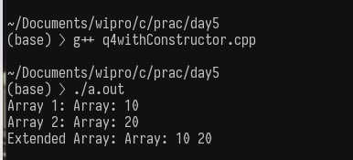

Q6. Swap 2 values
void swap(int *, int *);
void swap(int &, int &);
#include <iostream>
using namespace std;

void swap(int *a, int *b) {
int temp = *a;
*a = *b;
*b = temp;
}

void swap(int &a, int &b) {
int temp = a;
a = b;
b = temp;
}

int main() {
int x = 10, y = 20;

cout << "Before swap (Pointer): x = " << x << ", y = " << y << endl;
swap(&x, &y);
cout << "After swap (Pointer): x = " << x << ", y = " << y << endl;

cout << endl;

cout << "Before swap (Reference): x = " << x << ", y = " << y << endl;
swap(x, y);
cout << "After swap (Reference): x = " << x << ", y = " << y << endl;

return 0;
}

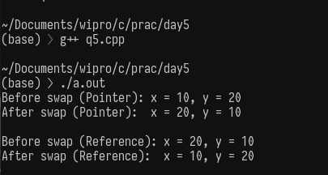

Q.7. Find min, max of values in an array. Pass arr along with Min and Max as reference or Address as argument.
void findMinMax(int *arr, int size, int &min, int &max);

#include <iostream>
using namespace std;

void findMinMax(int *arr, int size, int &min, int &max) {
min = max = arr[0];

for (int i = 1; i < size; i++) {
if (arr[i] < min)
min = arr[i];
if (arr[i] > max)
max = arr[i];
}
}

int main() {
int arr[] = {12, 5, 30, 7, 18};
int min, max;

findMinMax(arr, 5, min, max);

cout << "Minimum value = " << min << endl;
cout << "Maximum value = " << max << endl;

return 0;
}

